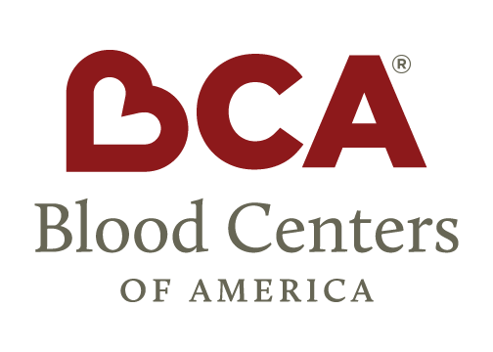
Contact Jennifer Ficenec  Telephone 401.381.0600  Cell 952-456-2208  Email jficenec@bca.coop  Website www.bca.coop | FOR IMMEDIATE RELEASE  October 7, 2016

Blood centers of america joins council for diabetes prevention
West Warwick, RI, October 7, 2016– Blood Centers of America is pleased to announce its membership in the recently formed Council for Diabetes Prevention to support the delivery of the Centers of Disease Control National Diabetes Prevention Program.
“BCA and its members are uniquely positioned to deploy the National Diabetes Prevention Program by leveraging our diverse footprint, mobility and our long standing trust in the communities we serve. This provides us an additional opportunity to better serve and support our donor population as well as the communities that have established many of our blood centers.”
-Bill Block, President/CEO Blood Centers of America
The Council for Diabetes Prevention brings together industry stakeholders to increase access to the National Diabetes Prevention Program, promote high-quality standards, and support the long-term scalability and sustainability of this unique patient-centric, community-based program.
# # #
About Blood Centers of America
Blood Centers of America (BCA) is a member-owned organization comprised of over 50 independent blood centers geographically dispersed throughout the North America across approximately 350 locations. Our members collect over 6 million blood components, representing nearly one third of the nation’s blood supply. Along with their core business of collecting and providing blood to US hospitals, BCA members provide a variety of other services including, patient blood management, transfusion services, immunohematology testing, therapeutic apheresis and tissue and cord blood banking. In addition, BCA members provide a variety of human blood products, cells and tissues to the therapeutic, diagnostic and cell therapy industries.

If you would like more information about this topic, please contact Jennifer Ficenec at 401.381.0600 or email at jficenec@bca.coop.

