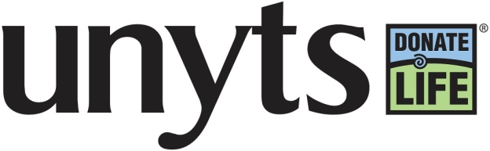
FOR IMMEDIATE RELEASE
July 10, 2017
Contact: Sarah Diina, 400-7249(c), sdiina@unyts.org

Unyts Community Blood Service Celebrates 10th Anniversary

2017 marks Unyts’ 10 year anniversary as Western New York’s only community blood bank. In 2005 Unyts was approached by a committee of area hospitals organized through the Western New York Purchasing Alliance under the premise that local hospitals had long been seeking an alternative with regard to obtaining blood. A subsequent feasibility study found that a community blood bank organized through Unyts was the best alternative.

Unyts started collecting blood in 2007, and has since become the primary supplier of blood products for Kaleida Health, ECMC, Niagara Falls Memorial Medical Center, Eastern Niagara Hospital and Wyoming County Community Health System.

Some notable statistics-

Unyts is responsible for over 60% of the blood needs in Western New York

In 2016 Unyts had over 23,000 whole blood, double red cell, & platelet pheresis donors, for a total of over 187,000 donors since June 2007.

In 2016 Unyts distributed over 45,000 blood, platelet and plasma products.

In 2016 848 Unyts blood drives were held across Western New York.

Since 2007 Unyts has worked with over 1500 community partners for blood drives

Since 2007 Unyts’ Community Blood Service has saved area hospitals over $10 million.
It is our responsibility to answer the call for blood at our local hospitals, and ensure that we are providing an adequate supply for patients in need. Every 2 seconds someone in the U.S. needs blood, and over 41,000 donations are required each day to meet this need. The very young, from the tiniest of preemies in a hospital’s neonatal unit, to an elderly patient suffering from a blood disorder, all benefit from blood’s life-sustaining qualities.

Naliah Codjovi from Cheektowaga is someone who requires blood products on a regular basis, and she depends on Unyts to make sure Women & Children’s Hospital of Buffalo has the blood she needs. Ten year old Naliah suffers from sickle cell disease, a blood disorder characterized by abnormally shaped red blood cells that obstruct the cells’ ability to carry oxygenated blood throughout the body. Therefore, Naliah must receive regular blood transfusions at Women & Children’s Hospital of Buffalo.

‘It means a lot to know that Unyts helps in providing the blood that Naliah and other children need to keep them healthy and make them feel better,” said Tarsha Graham, Naliah’s mom. “It benefits not only children with chronic illnesses, but also children and adults who find themselves in unexpected need.” “I urge others to donate because my daughter and many other children benefit a whole lot from this precious gift given by others,” said Tarsha.

Unyts needs continued help from the community to ensure that those in need, just like Naliah, are helped through blood donation. Blood drives are conveniently organized across Erie, Niagara and Wyoming Counties 6 days a week in addition to regular hours at four Neighborhood Blood Donation Centers. When you donate with Unyts you can be assured that your blood is staying local for local patients in need. The organization has grown dramatically over the last 10 years and will continue to do so as we remain committed to saving and enhancing lives across Western New York.

To learn more about donating blood or holding a blood drive with Unyts, please call 716-512-7940 or visit www.unyts.org.

###

*As of January 1, 2012, Unyts operates under, d/b/a Unyts, WNY’s only Organ, Eye, Tissue and Community Blood Center. The organization is no longer Upstate NY Transplant Services.

