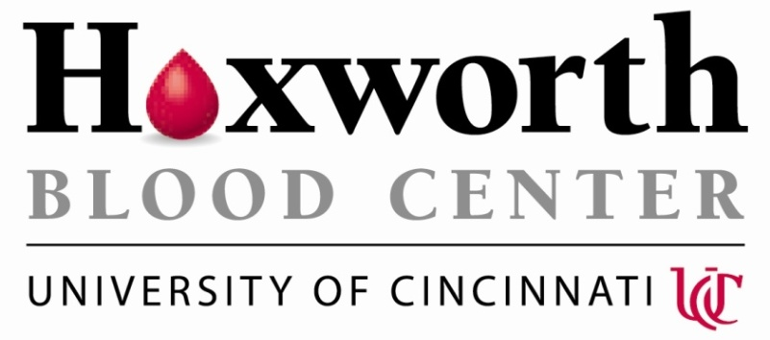

HOXWORTH BLOOD CENTER | NEWS RELEASE

Media Contact:
Alecia Lipton | Community Relations Manager
513.558.1296 | alecia.lipton@uc.edu

Jose Cancelas, MD, PhD, Named University of Cincinnati Hoxworth Director

FOR IMMEDIATE RELEASE

CINCINNATI (February 16, 2018)—Jose Cancelas, MD, PhD, has been named director of University of Cincinnati (UC) Hoxworth Blood Center. The appointment was effective Feb. 1.

Cancelas, who joined Hoxworth in 2002, has served in a variety of roles in the past 17 years. He was named Hoxworth division director of research in 2003, was appointed medical director for the Hoxworth Cellular Therapies Division in 2005, and has been Hoxworth deputy director since 2013.

“We are thrilled to be able to have strong leadership continue at Hoxworth Blood Center,” says William Ball, MD, UC senior vice president for health affairs and dean of the College of Medicine. “We have confidence that Dr. Cancelas can build on the accomplishments of Dr. Ronald Sacher, who helped Hoxworth become one of the leading blood banking centers in the United States.”

Cancelas replaces Ronald Sacher, MD, who served as Hoxworth Blood Center director from 2000 until Jan. 31, when he stepped down.
“Dr. Sacher has provided superb leadership in expanding research efforts and enhancing the well-being of patients in Greater Cincinnati by assuring a reliable and economical supply of the safest blood possible,” Ball added.

Cancelas, a native of Spain, received his medical degree from the Autonomous University of Madrid and a doctorate from the University of Alcala de Henares in Madrid, where he also did his residency. He also trained in the Cancer Research Institute of Barcelona and the Erasmus University of Rotterdam, The Netherlands.

Cancelas is a professor in the UC Department of Pediatrics and faculty in the Medical Scientist Training and Cancer and Cell Biology Programs at the UC College of Medicine. He serves as a leader in the Stem Cell Program, as an incumbent in the Beatrice C. Lampkin Endowment for Stem Cell and Hematotherapy and serves as a faculty member for the College of Medicine’s Molecular and Developmental Biology and Immunobiology Graduate Programs based at Cincinnati Children’s Hospital Medical Center.

About Hoxworth:
Hoxworth Blood Center, University of Cincinnati was founded in 1938 and serves 31 hospitals in 18 counties in Southwestern Ohio, Northern Kentucky and Southeastern Indiana. Annually, Hoxworth collects more than 70,000 units of blood from local donors to help save the lives of patients in area hospitals. Hoxworth Blood Center. All Types Welcome.

###

