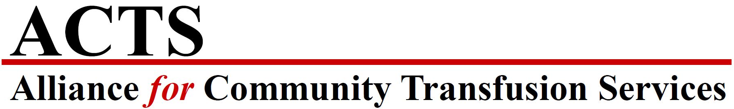
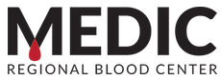

FOR IMMEDIATE RELEASE

May 28, 2021 – MEDIC Regional Blood Center in Knoxville, Tennessee joins the Alliance for Community Transfusion Services (ACTS) – a collaborative of independent blood centers committed to improving efficiency, operations, and opportunities to best serve donors and patients.

MEDIC Regional Blood Center in Knoxville, TN has joined twelve other independent blood centers in the Alliance for Community Transfusion Services (ACTS). ACTS was formed in 2010 to strengthen relationships between community blood programs and their local hospitals.

“We’re excited to announce the addition of MEDIC Regional Blood Center to the ACTS Alliance,” said Nelson Hellwig, Chief Executive Officer of ACTS. “With a long history of service to their hospital partners, and under Jim Decker’s leadership, MEDIC’s transfusion expertise and culture of service will perfectly align with the rest of our members. We are gratified to strengthen our alliance through enhanced best practicing, resource sharing, and strategic programming.

“We are thrilled to join the Alliance for Community Transfusion Services,” said Jim Decker, Chief Executive Officer of MEDIC. “Being part of this alliance will allow us to better serve our community through collaboration with the other blood center members. This is an exciting step for us.”

About MEDIC Regional Blood Center
MEDIC was established in 1958 by Carl Nelson, MD, under the sponsorship of the Knoxville Academy of Medicine. MEDIC is a nonprofit organization and offers a Blood Coverage Program covering members’ blood supplier processing fees at any hospital in the country. MEDIC is an accredited member of AABB (formerly American Association of Blood Banks) and America’s Blood Centers (ABC). MEDIC is a member of the Alliance for Community Transfusion Services (ACTS) and Blood Centers of America. The center adheres to all blood product safety regulations established by the U.S. Food and Drug Administration and is licensed by the FDA and the State of Tennessee. MEDIC is an independent blood center and not affiliated with the American Red Cross. Today, MEDIC Regional Blood Center is the provider of blood and blood-related products for the 24 area hospitals in 22 counties East Tennessee and Southeastern Kentucky.

About the Alliance for Community Transfusion Services
The Alliance for Community Transfusion Services (ACTS) is a strategic and operational alliance of independent blood centers that annually collect, process, and distribute more than 1.5 million blood products to over 750 healthcare facilities and provide various technical services, therapeutic treatments and cellular laboratory operations throughout the United States. Other ACTS members include Carter BloodCare (Dallas/Fort Worth, TX), Central Pennsylvania Blood Bank (Hershey, PA), Coastal Bend Blood Center (Corpus Christi, TX), Community Blood Center of the Ozarks (Springfield, MO), Houchin Community Blood

Bank (Bakersfield, CA), LifeShare Blood Center (Shreveport, LA), Oklahoma Blood Institute (Oklahoma City, OK), Shepeard Community Blood Center (Augusta, GA), South Texas Blood and Tissue Center (San Antonio, TX), SunCoast Blood Centers (Sarasota, FL), Community Blood Center (Appleton, WI) and We Are Blood (Austin, TX).

ACTS members collectively meet challenges of the business environment through shared resources, initiatives, and expertise. Through this unique collaboration, ACTS members enjoy the economic benefits typically associated with large centralized operations without sacrificing the qualitative benefits of independent, community blood banking.

# # #

MEDIC Regional Blood Center Media Contact:
Kristy Altman
(865) 521-2663
kaltman@medicblood.org

Alliance for Community Transfusion Services Media Contact:
Nelson Hellwig, MBA
(504) 575-2139
nelson.hellwig@actscorp.org

