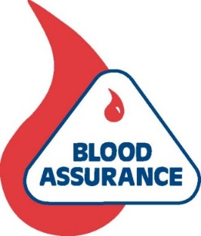
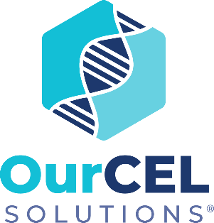

FOR IMMEDIATE RELEASE
Contact: Max Winitz
maxwinitz@bloodassurance.org
(615) 772-6681

BLOOD ASSURANCE OPENS ITS CELLULAR THERAPY DIVISION, OURCEL SOLUTIONS, IN NASHVILLE

NASHVILLE, Tenn. (May 8, 2023) – Blood Assurance has established a lifesaving cellular therapy division, becoming the first blood center in Tennessee to do so.

On Monday, a grand opening was held at OurCEL (Cellular Therapy-Exchange-Laboratory Services) Solutions, located at 2817 West End Ave. #200 in Nashville.

Cell therapy is the transplantation of human cells to replace or repair damaged tissue and/or cells belonging to those battling cancer and autoimmune diseases.

“Blood Assurance has provided life-saving blood products to support patients in our community for over 50 years,” said Dr. Liz Culler, Blood Assurance’s chief medical officer. “We are excited to start the OurCEL Solutions division so that we can provide physicians and researchers with living cells as a drug to directly treat disease.”

The nearly 8,000-square-foot center gives individuals several donation opportunities:

-Leukapheresis: A procedure in which white blood cells are separated from the blood. The procedure is performed to decrease a high white blood cell count, to obtain blood cells from a patient or donor for later transplant into the patient, or to obtain the cells for research.

-All of Us Research Program: OurCEL Solutions is the only blood center in Tennessee collecting blood samples for The National Institutes of Health’s program. All of Us aims to collect genetic and health data from 1 million volunteers. Its mission is to accelerate health and medical breakthroughs, enabling individualized prevention, treatment and care. More information can be found at: www.allofus.nih.gov

-Standard blood donations: Whole blood, double red cells, platelets and plasma used to treat patients at local hospitals.

-Sipuleucel-T (Provenge): Sipuleucel-T is an established cellular immunotherapy for men battling advanced prostate cancer. Immune cells are collected from the patient and exposed to a protein that targets cancer cells. The immune cells are then given back to the patient to help treat the cancer.

Shelley Dishman, a Cookeville resident who was diagnosed with lupus a few years ago, is hoping Middle Tennesseans will rally around the new center.

“I’ve suffered many health complications since being diagnosed,” according to Dishman. “I don’t want others to have to go through the same things I’ve been dealing with. This is a great opportunity to help those suffering from autoimmune disorders like me.”

All OurCEL Solutions donors will be given a gift card. The amount varies based on the type of donation.

Donors can schedule an appointment online at www.ourcelsolutions.org, or call (629) 736-2320.
To be eligible to donate, you must be at least 17 years old (16 years old with parental consent), weigh 110 pounds or more and be in good health. Donors are asked to drink plenty of fluids — avoiding caffeine — and eat a meal that is rich in iron prior to donating.

About Blood Assurance
Blood Assurance is a nonprofit, full-service regional blood center serving more than 70 health care facilities in Tennessee, Georgia, Alabama, Kentucky and North Carolina. Founded in 1972 as a joint effort of the Chattanooga-Hamilton County Medical Society, the Chattanooga Area Hospital Council and the Chattanooga Jaycees, the mission of Blood Assurance is to provide a safe and adequate supply of blood and blood components to every area patient in need.

About OurCEL Solutions
OurCEL (Cellular Therapy-Exchange-Laboratory Services) Solutions is a nonprofit cellular therapy and research division of Blood Assurance. The mission of OurCEL is to improve the lives of patients by supporting the development of medical therapies including cell and gene therapy.

###

